|  |
| --- |
| Designers’ *Handbook*  -By Sudev Suresh Sreedevi |

***Index of Contents***

|  |  |
| --- | --- |
| *Heading* | *Page Number* |
| Preface | 3 |
| Introduction | 5 |
| Color Scheme | 5 |
| Logo  Paddings | 6  6 |
| Fonts | 7 |
| Post Guidelines for Instagram and Whatsapp  Posters  Components of poster  Instagram Carousels  Stories / Statuses | 8  8  9  10  11 |
| Resources | 13 |

**TinkerHub CETDesigners’Handbook**

*(2021 Edition)*

*-By Sudev Suresh Sreedevi*

***Preface***

Hello there! Welcome and congrats on becoming a designer for TinkerHub CET! We are so happy to have you in the team.

This book is just a general suggestive guide for making your design process easier while you are designing for TinkerHub CET, and to help you stay consistent on your style. This book will also contain quick links to resources.

Please do note, that this is NOT a rulebook of any sorts. These are just recommendations which will help keep our overall branding seem “professional” as such.

Your design choices and artistic freedom is given as much, or maybe more, importance than the content in this book. Feel free to go crazy with your design!

This book is open to suggestions and contributions by you as well, so feel free to suggest edits or additions of any kind. And for aiding in this contribution, this book shall be open sourced and made available on GitHub so that any one may fork and contribute to its contents, as well as get inspired from our idea.

I hope you find this book enjoyable and worthwhile. Have fun!

Happy Designing,Cheers,Sudev Suresh Sreedevi. (2021 Design Lead)

***Introduction***

You are most likely to have received this e-book along with a zip file named **‘*Designer’s Toolkit*’**, containing the components to help you in designing.

***Color Scheme***

The following color scheme is derived from our TinkerHub Logo. Feel free to use any colors as you wish, although just do **try to include some or few of these colors** in our design. (Poster Guidelines coming up). Don’t mind the naming scheme. Those are just random names I came up with :)

|  |  |  |  |
| --- | --- | --- | --- |
| ***Neutrals*** | | | |
|  | #1A1F20  (26, 31, 32) |  | #FFFFFF  (255, 255, 255) |
| TinkerCET Black | White |
| ***Primary******Colors*** | | | |
|  | #205B67  (32, 91, 103) |  | #FFCD10  (255, 205, 16) |
| Tinker Teal | Tinker Yellow |
| ***Secondary******Colors*** | | | |
|  | #95BF15  (149, 191, 21) |  | #05BFCE  (5, 191, 206) |
| Tinker Green | Tinker Cyan |
| ***Accent******Colors*** | | | |
|  | #0060FF  (0, 96, 255) |  | #EE1700  (238, 23, 0) |
| Tinker Blue | Tinker Red |

(Color Scheme JPEG file and PSD included in toolkit. Import it to your project file for quick color picking)

***Logo***

TinkerHub Foundation has a logo of its own, as well as TinkerHub Campus Logos. The Campus Logos are generated using the **Campus Logo Generator** at:

<https://tinkerhub.org/campus-logo-generator/>

Although the Dark Mode and Light Mode logo (the White text and Black text logos, respectively) are **included in the toolkit**, if you ever find yourself not having our TinkerHub CET logo, go to the site and enter **CET (not College of Engineering Trivandrum)** to generate a logo for yourself.

***Paddings***

A generated logo will already be having an approximate **10% padding** of its own.



Fig. 1 – Official logo image boundaries

Try to limit our design content to not invade the Logo Image Boundary (i.e. between the purple and yellow lines in Fig 1). Do **keep this in mind** when we design posters, stories and videos.

Original Boundaries of the logo image

Boundaries of logo content

If you have maybe salvaged the logo from somewhere else and it does not have such a padding already, try to at least keep as much padding as the width of the ‘**b**’ in ‘TinkerHub’

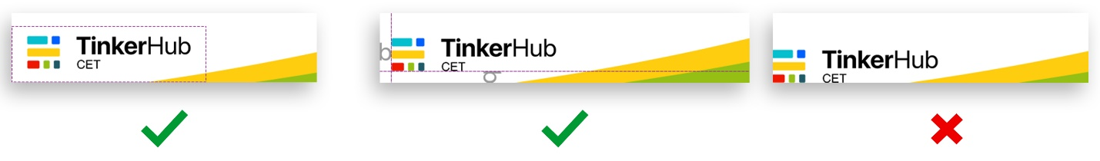

Fig 2 – Recommended padding in a typical poster corner

The **‘b’** suggestion is just for an approximate reference and for conveying the idea of the least minimum padding necessary. (Fig 2).

*Fonts*

The font choice for the design is completely left to the **designer’s artistic freedom**. Just in case, you are stuck or out of time to spend thinking over font choices, here are some [free] font suggestions. Ctrl+Click on the picture to open its corresponding Google Fonts page **(these fonts are included in the toolkit as well)** :

[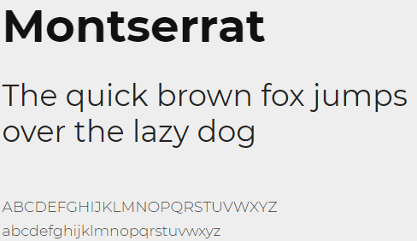](https://fonts.google.com/specimen/Montserrat?query=monts&preview.text_type=custom)[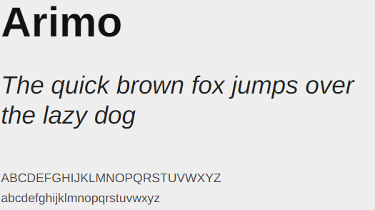](https://fonts.google.com/specimen/Arimo?query=arimo&preview.text_type=custom)

[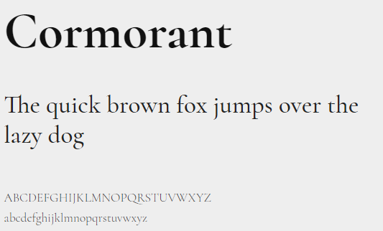](https://fonts.google.com/specimen/Cormorant?query=cormorant&preview.text_type=custom)

***Post Guidelines (for Instagram and WhatsApp)***

We, as designers, would be tasked with a lot of posters to be made for our programs and activities. Hence, it’s important to maintain certain levels of consistency.

We would be making one of two kinds of poster – **Dark themed** or **Light Themed**. These two **themes must alternate** between every poster made. That is, if the previous poster was light themed, the next poster *should be* dark themed. This is to bring up a sort of “checkerboard” color pattern to our Instagram feed.

***Posters***

**Do make sure that the base background color is the exact one mentioned here.** This is for ensuring the earlier mentioned checkerboard pattern in Instagram. The base text color is mentioned for easier and more comfortable visiblity, although you are completely permitted to use whichever text color according to the need.

|  |  |
| --- | --- |
| Light Theme | D:\old laptop transfers\zarucksack\TinkerHub\Execom\TinkerHub CET - Design Handbook\Light Poster.jpg |
| ***Dimensions***: 2000px × 2000px (minimum) |
| ***Base background color***: #FFFFFF  (255, 255, 255)  ***Base text color***: #1A1F20 (26, 31, 32) |
|  |
|  |  |
| Dark Theme |  |
| ***Dimensions***: 2000px × 2000px (minimum) |
| ***Base background color***: #1A1F20  (26, 31, 32)  ***Base text color***: #FFFFFF  (255, 255, 255) |
|  |

We are free to use any illustrations, icons or stock images as we please. And there are no restrictions for adding any sorts of graphic shapes. We may also add textures or gradients, as long as it does not become the main background of the image.

***Components of poster***

Ensure to include all of these pieces of information in our posters:

1. Posters for workshops, seminars
   1. Event name
   2. Event topic (eg.: “Workshop on Git”, “Introduction to Web Dev”, etc.)
   3. Time
   4. Date
   5. Registration or meet links (if any)
   6. Venue (if offline event)
   7. Contact Detail(s)
   8. One illustration of some kind
   9. TinkerHub Logo
   10. Secondary Logo(s) (if any. This could be other clubs, sponsors, etc.)
2. Posters for Tech Talks, Interviews
   1. Event name
   2. Event topic
   3. Time
   4. Date
   5. Registration or meet links (if any)
   6. Venue (if offline event)
   7. Contact Detail(s)
   8. Photo of the speaker/guest
   9. Name and info of the speaker/guest
   10. TinkerHub Logo
   11. Secondary Logo(s) (if any)
3. Posters for congratulating
   1. Person’s photo
   2. Person’s name
   3. Person’s year and department
   4. Achievement
   5. TinkerHub Logo

Run through these like a checklist when you are asked to make a poster. It will help us ensure that we haven’t missed out any key information, and we can avoid having to go through a gazillion revisions to add each of them. ☺

We as designers will be collaboratively designing templates for special stuff like TinkerHub Learning stories, TinkerHub Meetup, TinkerHub Townhall, etc.

***Instagram Carousels***

Posting in Instagram as carousels ensures longer user interaction, and in turn a higher popularity rating according to the Instagram algorithm. Also, **interactions other than ‘likes’, are valued higher**. The value of Instagram interactions, in their respective descending order of importance are:

1. Save
2. Share
3. Comment
4. Like

As you can see, although *“Likes”* are important, at least some of our posts should be worthy enough for other interactions. So occasionally, we would have to release posts that are useful to the users (**such as tech tips, resource links, advices, ideas, etc.**) so that they may save or share the content, rather than simply double-tapping and scrolling away.

Therefore, making a single poster is most often enough for WhatsApp forwards, but when it comes to Instagram, the **most recommended method would be to have two or more pages in a single post**. Don’t panic! Here’s the deal.

The cover page of the post (i.e. the content seen on the feed) will be the amazing poster that you would’ve spent your time creating and pouring your idea over. The rest of the pages (i.e. page 2 and above) can be simply somewhat plain text templates describing the event or purpose of the poster, shortly.

These secondary pages, would require a continuity element. Therefore these secondary page templates will be designed according to the dark and light themes as mentioned earlier.

Such text pages will be useful, especially if we were to deal with TinkerHub Learning Stories, or Workshops and Events. These text pages aren’t necessary for congratulation posters. The content of the text pages would be curated and provided to you by a content team of writers.

***Stories / Statuses***

Every Poster is made so that it can be shared via Status in WhatsApp, or Stories in Instagram. In Instagram, we can simply share using the share to story, and it will add its own colour with a drop shadow. But in WhatsApp, it will just look like a plain square picture. So, for a general aesthetic consistency, place your poster in a status holder (these are placeholders for your posters, with a background color, and drop shadow like Instagram. **Included in the toolkit**) before sharing in WhatsApp.

|  |  |
| --- | --- |
|  |  |
| **Dimension**: 720*1280px  **Background**: #FFFFFF  **Drop Shadow**:  Opacity - 35%,  Distance(Y) - 95px,  Blur (Size) - 250px,  Angle - 0º  *[Units written according to Photoshop units]* | **Dimension**: 720*1280px  **Background**:#1A1F20  **Drop Shadow**:  Opacity - 55%,  Distance(Y) - 87px,  Blur (Size) - 100px,  Angle - 0º  *[Units written according to Photoshop units]* |

Fig. 1 – Status Holders for Posters

***Resources***

Once again, we are so happy to have you in our design team! Thank you for going through the whole Handbook that we have made with so much care and love. Remember to have fun designing!

Here are some resources to let you blaze through your design process.🔥 And like the entire book, you are absolutely encouraged to contribute and expand this list.

***Illustrations and icons***

* [freepik.com](http://freepik.com)
* [material.io](http://material.io)
* [undraw.co](http://undraw.co)

***Stock Images***

* [unsplash.com](http://unsplash.com)
* [pexels.com](http://pexels.com)
* ~~images.google.com~~ *(Dude no. You aren’t banned from using it though; just try to limit from it. Sometimes cliché or copyrighted stuff could creep up)*

***Designer Instagram pages***

* [ui_gradient](https://www.instagram.com/ui_gradient/)
* [uxcel.app](https://www.instagram.com/uxcel.app/)
* [uiuxdailytips](https://www.instagram.com/uiuxdailytips/)